Grade 8 - Term 2: The Mineral Revolution in South Africa
SECTION C
Deep Level Gold Mining on the Witwatersrand from 1886 onwards
Why is Gold Valuable?
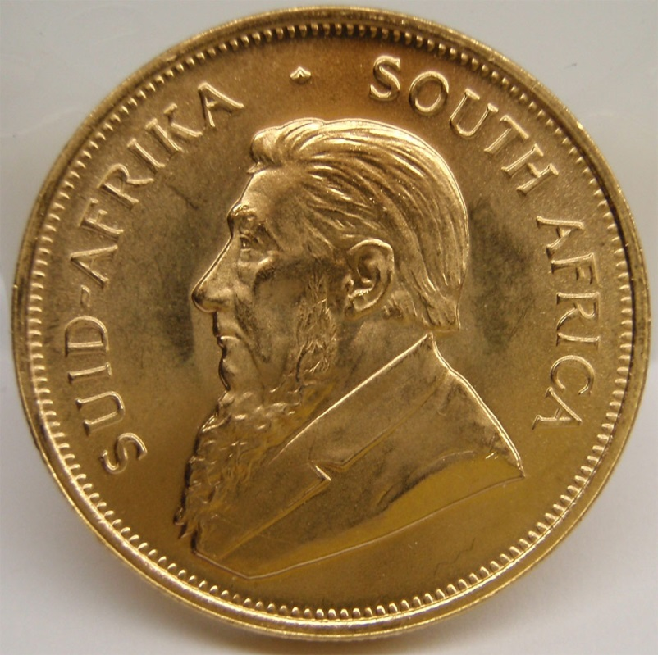A South African Krugerrand Gold Coin Image source
For thousands of years it has been used as a bauble of kings, a standard for global currencies, in competitions as symbol of victory and more recently, in a wide range of electronic devices and medical applications. Ancient civilizations used gold for the decoration of tombs and temples. Gold is a dense, soft, shiny, malleable, and ductile metal. It is a chemical element with the symbol Au and atomic number 79 with a symbol of Au. Gold is the most malleable and ductile of all the metals, and it is important to consider that gold is rather scarce.It's quite hard to find and extract in large quantities with pre-industrial technology. Its principal characteristics of being highly corrosion-resistant and easily worked made it highly desirable (and still do) for decorative purposes, and even more so industrially, e.g. where you need high quality electrical connectors.
Discovery and mining of deep level gold on Witwatersrand
How is Gold mined in South Africa?
Gold mining in South Africa typically involves methods such as panning, sluicing, dredging, hard rock mining, and by-product mining. For most effective gold mining in South Africa, the method used is hard rock mining, since reserves are typically fully encased in rock deep underground. The invention of industrial air cooling and air quality control systems saw gold mines reach unprecedented depths – the deepest being 3 900 metres. This method is accompanied by chemical beneficiation, where chemicals, such as cyanide, or activated carbon are added to rough ore and processed – sometimes with heat, water, agitation, electro-winning etc. Modern gold beneficiation methods can produce gold of 99.9999% purity. Making the refining process more thorough and economically viable, gold mining in South Africa projects, such as the ERGO Mines Joint Venture in Brakpan, will facilitate the re-processing of 1.7 billion tonnes of gold tailings to refine a further 15 million ounces of gold.Over 50% of all gold reserves are found in South Africa, where the Witwatersrand holds the world’s largest gold reef deposit. In 2007, gold mining in South Africa employed over 240 000 people and accounted for R49 billion in foreign currency earnings.
Conditions Underground
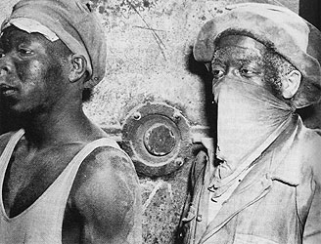A mineworker trying to protect himself from the dust in the mines Image source
One of the legacies of Randlords to mining in the country is the poor working conditions of many Black South Africans. Slowly this has improved but it remains a problem. Compared to other countries, South African mines are composed of ore bodies which are formed from ore minerals and waste rocks. It has its benefits in that it allows mining companies to dig deeper than anywhere else in the world. On the other hand, the mining area becomes unbearably hot and narrow. Another problem with mining in the country is the silica dust which can cause silicosis, a lethal lung disease. Machines cannot be used in the depths of the mining caves which mean human labour is the only option for now.
Randlords and the formation of the Chamber of Mines
Within a few years of the discovery of gold in 1886 the gold mines of the Witwatersrand brought riches undreamed of to the government and to the Randlords, a relatively small group of financiers and magnates at the apex of the mining industry. They discovered the value of setting up a ‘group system’ – five or six main ‘groups’ or ‘finance houses’ that exercised control of several mining companies by way of the shares they held. There was no competition between corporations for markets, and companies could sell all the gold they produced. The profits they made were to a decisive extent determined by their ability to cut costs, particularly labour costs. They realised that South Africa must change in important ways if their mines were to be as profitable as they wanted them to be.Thus they formed the Chamber of Mines in 1887 to eliminate competition among them for labour. They also shared technological advances that brought down labour costs. The Chamber of Mines became a powerful organisation serving the mining companies and getting them to agree to common policies on wages, finding workers and how to deal with the government.
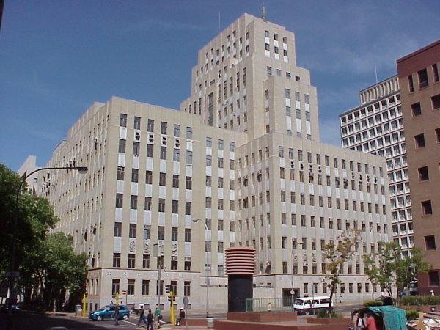Chamber Of Mines Building, Johannesburg Image source
The Chamber's primary functions are described as being to promote and protect the interests of its members, doing this through joint action, at industrial level in areas where it is considered by the Chamber to be economically beneficial, prudent and desirable for members to co-operate and act in concert. It operates through a range of committees on which sit representatives of the major finance houses and mining companies and at which policy agreements are arrived at.
Questions
- Gold can be put to a variety of uses. Mention any four such uses.
- Explain the following terms: scarce, malleable, ductile, pre-industrial technology, corrosion resistant and Randlord.
- Describe the mining of gold in SA.
- Historically, working conditions have been bad on the mines in South Africa as established by research in recent times. Explain why this was so.
- What was the Chamber of Mines? Explain the function of this body.
SECTION D

Migrant Workers and Mining
"Migrant labour" in South Africa referred not only to workers coming into South Africa from neighbouring countries, but also to a system of controlling African workers within South Africa. Migrant labour provided abundant cheap African labour for white-owned mines and farms (and later factories) and, at the same time, enforced racial segregation of land. Male migrants employed by white-owned businesses were prohibited from living permanently in cities and towns designated for whites only. Hundreds of thousands of African men lived in crowded single-sex hostels near their jobs and were not allowed to bring their wives and children, who were described as "superfluous appendages."The mining industry was locked into the migrant labour system which gave it a control over the labour force so that there was no question of strikes, which were illegal, and there was dominance of management over labour. By 1910, workers were being recruited from all over Southern Africa but far from Johannesburg itself.
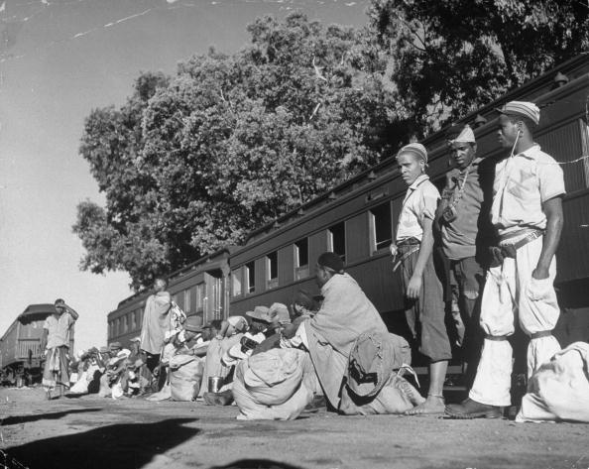
Migrant Workers Image source
Impact of Mining on Women and Families
Miners were usually recruited from all over the country, thus provisions needed to be made with regards to their living conditions. They were instructed to live in compounds, which in effect became the compound/ hostel system. This compound/ hostel system, however, had adverse effect on the health and well-being of its occupants. Too many people living together in a small space with inadequate ventilation must inevitably increase the spread of disease. The living in hostels contributed to the spread of tuberculosis and HIV-related diseases. Stress and strain of a psychological nature is also involved. There is a lack of privacy and husbands are separated from their wives and children. Hostel life estranges the husband from his family. Women were left behind to care for children and perform domestic labour.
Skilled and Unskilled White Workers
White workers had more power than the black workers and could challenge the mine-owners directly, through strikes, through political parties and through newspapers. They were fighting against the mine-owners' continual attempts to replace 'expensive' white labour with 'cheap' black labour. Most of the skilled miners came from the mines of Britain - from Cornwall or Northumberland in England, and from the mines of Scotland and Wales. Many others came from the coal mines of Australia. These new immigrants brought with them not only mining skills they also brought their experience of being workers and we shall see later how important this was. They came to the Rand as full-time workers, with no land to go back to. The skilled miners of the early years had a strong influence on the working conditions of white workers in the years to come.
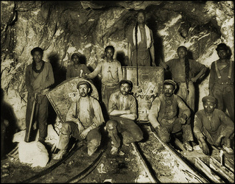White Mine workers in a Johannesburg Mine. Image source
Skilled miners in South Africa got high wages. In 1897, for example, skilled miners earned 18 pounds to 22 pounds a month. That was good pay in those days, while unskilled miners were earning only two to three pounds a month.One reason for the skilled workers’ high wages was that the mines desperately needed skilled workers, as we have seen. So, from the earliest days, mine-owners offered high wages for skills, and skilled miners were in a strong position. Most of these miners saw themselves as members of the working class. They organised themselves into unions soon after they arrived. They had experience of trade unions in the countries that they came from, and they knew how to bargain for higher wages and better working conditions. The skilled miners knew how important the gold mines were to South Africa - and how important their skills were to the gold mines.
The Anglo Boer War led to the closing of the gold mines for two years. After the war there was a shortage of cheap labour. This was partly because the mine-owners tried to drop the wages of black workers. Thousands of men stayed away from the mines. Mine-owners then tried using unskilled white labour, but the skilled miners were against this plan. They were worried that these unskilled whites would not be properly trained and that they would take over the skilled jobs at lower wages. Then the mine-owners could lower the wages of all skilled miners.
Questions
- Explain the following terms: migrant worker, mining, racial segregation, prohibited, ‘superfluous appendages,’ and illegal.
- In your opinion, why did the white mine, farm and later factory owners prefer the migrant labour system? Explain in detail.
- How did the migrant labour system affect women and family life?
- Who were the skilled and unskilled white workers? Explain in detail.
- Their skills and experience affected the future of labour organisation on the mines. Do you agree? Motivate your answer.
- How did the Anglo-Boer war(1899-1902) affect the gold mines?

Section E
Forms of Labour resistance
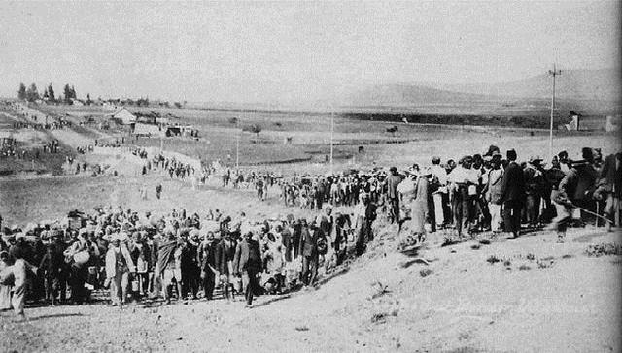The Indian Mineworkers Strike in 1913 Image source
A form of resistance included to look for better jobs. After the South African War (1899-1902), thousands of African workers boycotted the gold mines because wages had dropped. They tried to find jobs on the railways and in the towns instead. As with indentured labourers, workers on the gold mines also deserted when they were unable to do anything else to improve their jobs. Where conditions in compounds were the worst, desertion was higher. Many workers also tried to limit their work by deliberately working badly, breaking their tools and not doing any more work than they had to. Often workers acted dumb by pretending that they didn't understand their orders. Although employers could have their workers tried for these 'crimes', the courts were often ineffective. As a result, there was very little employers could do to put a stop to many of these 'everyday' forms of resistance.
In 1913, African miners went on strike over wages and conditions in the compounds. White miners also went on strike over the number of hours they were expected to work on a Saturday. During 1920, Almost 70 000 African miners went on strike to demand a wage increase. Of the 35 mines, 21 were brought to a standstill during the strike. After the protest by white miners in 1913, the Chamber of Mines recognised white trade unions in 1914. Production increased between 1911 and 1920. This was a period of stability and profit for the mine owners. But by 1920 the price of gold was dropping and the mine owners were facing greater resistance from African workers.
City of Johannesburg
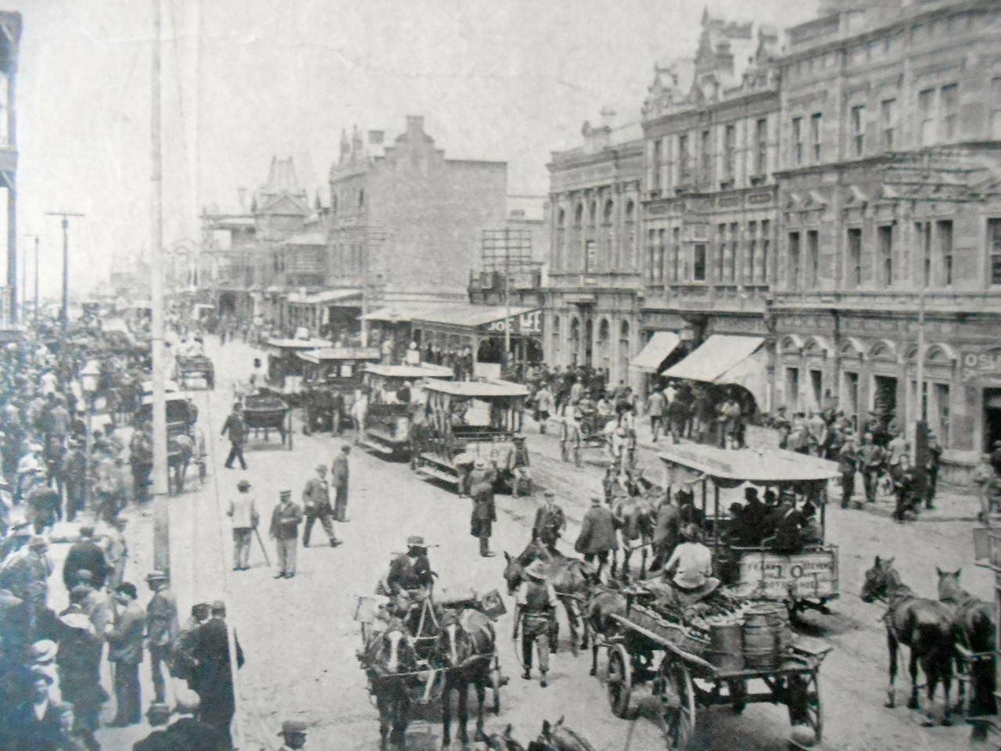Johannesburg in the early 1890's Image source
Gold was discovered in the City of Johannesburg in 1886 which rapidly led to urbanisation within the town and becoming one of the biggest cities in the country.Although Johannesburg only became officially a city in 1928 it was set up as a town as early as 1886. The town was set up on a piece of land that was previously a farm called Randjieslaagte. At that time the Government owned the property and auctioned off 980 stands which lead to the establishment of the town. Gold was discovered in the 1880s and triggered the gold rush. Gold was initially discovered some 400 km to the east of present-day Johannesburg, in Barberton. Gold prospectors soon discovered that there were even richer gold reefs in the Witwatersrand. Gold was discovered at Langlaagte, Johannesburg in 1886.
Johannesburg was a rough and disorganized place, populated by white miners from other continents, African tribesmen recruited to perform unskilled mine work, African women beer brewers who cooked for and sold beer to the black migrant workers, a very large number of European prostitutes, gangsters, impoverished Afrikaners, tradesmen, and Zulu "AmaWasha," Zulu men who surprisingly dominated laundry work. As the value of control of the land increased, tensions developed between the Boer government in Pretoria and the British, culminating in the Jameson Raid that ended in fiasco at Doornkop in January 1896 and the Second Boer War (1899–1902) that saw British forces under Lord Roberts occupy the city on 30 May 1900 after a series of battles to the south of its then-limits.
Major building developments took place in the 1930s, after South Africa went off the gold standard. In the late 1940s and early 1950s, Hillbrow went high-rise. In the 1950s and early 1960s, the apartheid government constructed the massive agglomeration of townships that became known as Soweto (South Western Townships). New freeways encouraged massive suburban sprawl to the north of the city. In the late 1960s and early 1970s, tower blocks (including the Carlton Centre and the Southern Life Centre) filled the skyline of the central business district. The central area of the city underwent something of a decline in the 1980s and 1990s, due to crime and when property speculators directed large amounts of capital into suburban shopping malls, decentralised office parks, and entertainment centres. Sandton City was opened in 1973, followed by Rosebank Mall in 1976, and Eastgate in 1979.
Questions For Class Work
- Explain the following terms: indentured labourers, desertion, resistance, urbanisation, prospectors and aprtheid.
- What methods were used by South African/Black mine workers to show their discontent/unhappiness with their conditions of work on the mines? What resulted from their actions? Why?
- In not more than 10 lines, describe the gradual development of the city of Johannesburg between 1928 and 1979.

